PRESS RELEASE
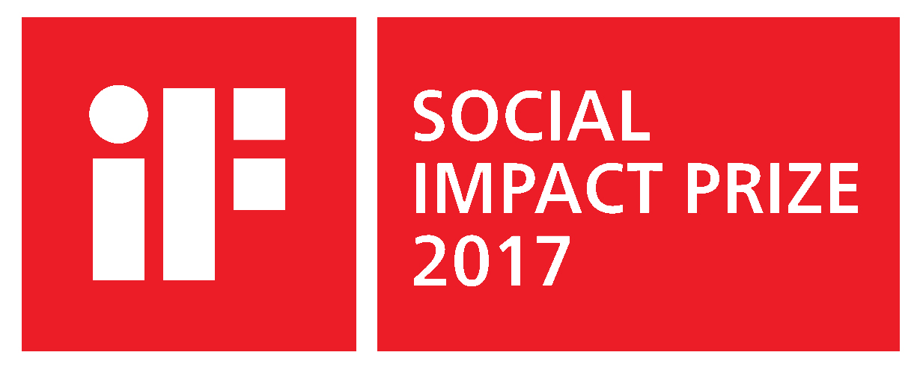

Hannover, 27 April 2017

NEW: iF SOCIAL IMPACT PRIZE 2017

With the new iF SOCIAL IMPACT PRIZE, iF offers a prize of EUR 50,000 to projects that are worthy of financial support and serve public interests.

This prize invites companies, design studios, NGOs, foundations, public institutions and other organizations from all over the world to take part free of charge starting immediately.

All currently existing projects that contribute to meeting the social challenges of our times – regardless of whether they are CSR programs, individual initiatives or special measures introduced for the long term – are eligible to take part in the iF SOCIAL IMPACT PRIZE. A prize money of EUR 50,000 will be shared to the best of all the projects entered by 15 November 2017.

“The size of the project is irrelevant – what counts are the ideas on how to deal with the social challenges we face. In addition to our active promotion of young, new talent, this prize is our contribution to society. What we aim to do is to make the many, diverse social activities and commitment of people and organizations more visible, to honor those efforts and to award prize money to the best entries,” says iF CEO Ralph Wiegmann about the new initiative.

All the projects that are entered in the iF SOCIAL IMPACT PRIZE 2017 and compete for the prize money will also be published free of charge in the iF WORLD DESIGN GUIDE, the world’s largest design portal – for an unlimited period of time. This means that all the projects participating will be presented to the large-scale, global design community, the media and the broader public audience interested in design in general.

These are the topic areas covered by the iF SOCIAL IMPACT PRIZE 2017:

1. Life & Work
2. Health & Demographic Change
3. Places & Cities
4. Nature & Planet

All the details regarding registration for the iF SOCIAL IMPACT PRIZE 2017 are available at: www.ifworlddesignguide.com.

For more information, please contact:

Annegret Wulf-Pippig
Press officer
iF International Forum Design GmbH
Bahnhofstrasse 8, 30159 Hannover (Germany)
Phone +49.511.54224-218
annegret.wulf-pippig@ifdesign.de
www.ifworlddesignguide.com

